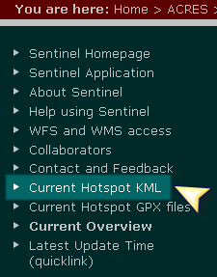
http://sentinel.ga.gov.au/acres/sentinel/index.shtml
on the left margin select current Hotspot KML & this goes to the next screen that has this at the top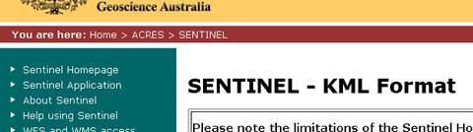
and the bottom page looks like this:-
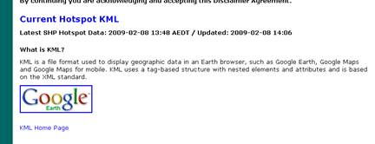

select the Current Hotspot KML and you get this selection

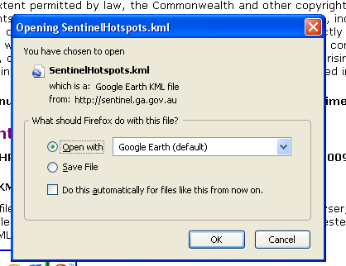
This integrates with Google Earth.

Also you can check Sentinel
